7. Create a Virtual Machine with 1 CPU, 2GB RAM and 15GB storage disk using a Type 2 Virtualization Software,

using virtual box.

AIM:
To create a virtual machine with 1 cpu, 2gb ram and 15gb storage disk using a type 2 virtualization software.

PROCEDURE:
STEP 1:Dowload VMware workstation and installed as type 2 hypervisor.
STEP2:Dowload ubuntu or tiny OS as iso image file. STEP 3: In VMware workstation->create new VM. STEP 4: Do the basic configuration settings.
STEP 5: Created tiny OS virtual machine. STEP 6: Launch the VM.

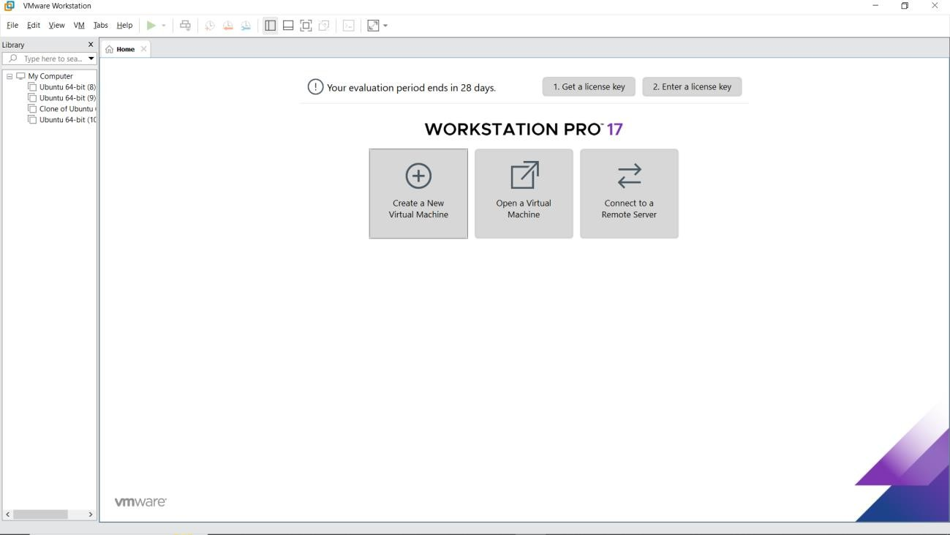
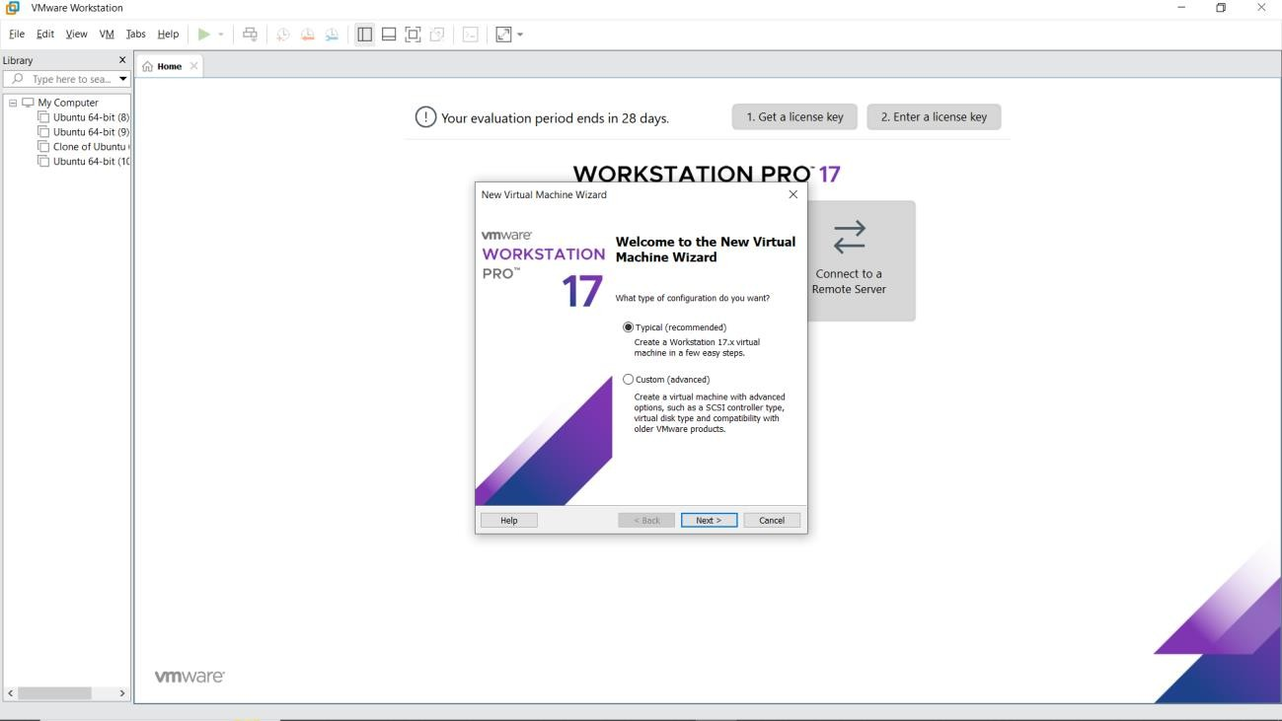
IMPLEMENTATION

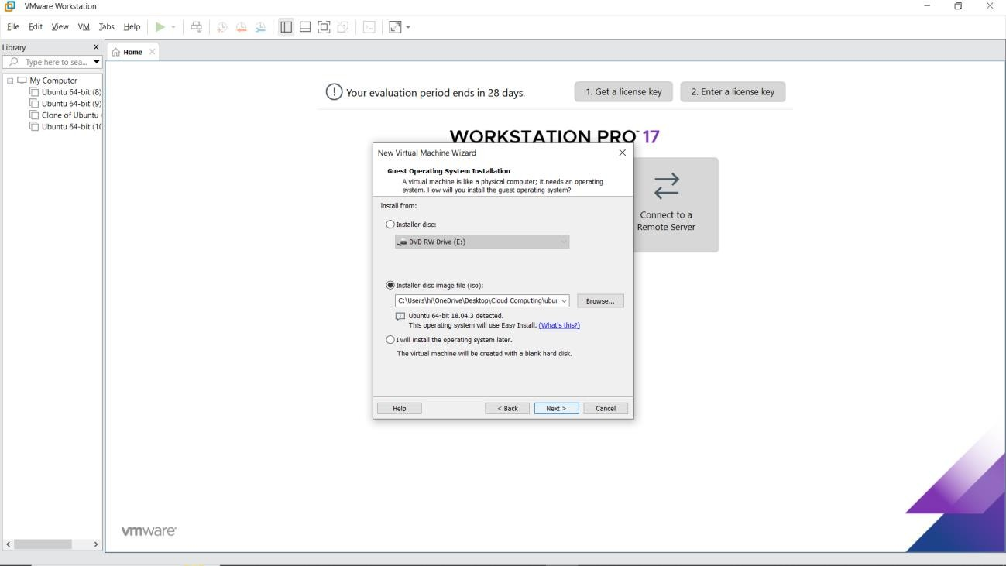
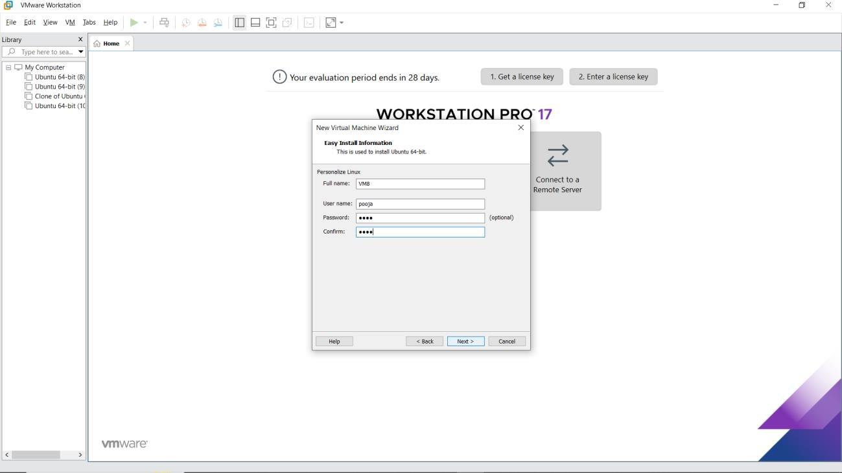

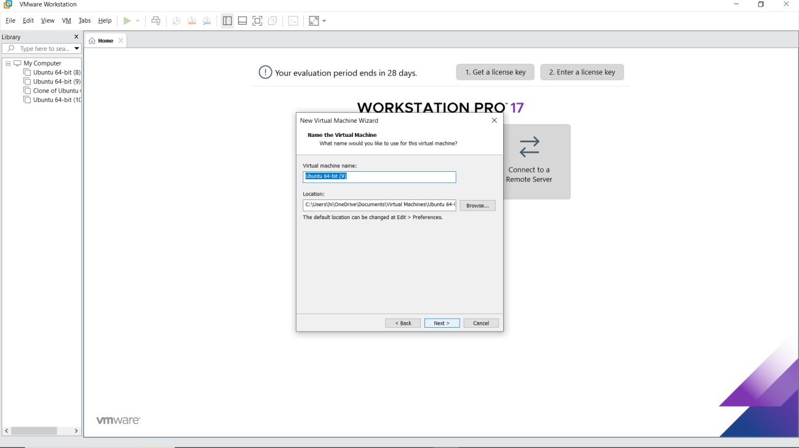
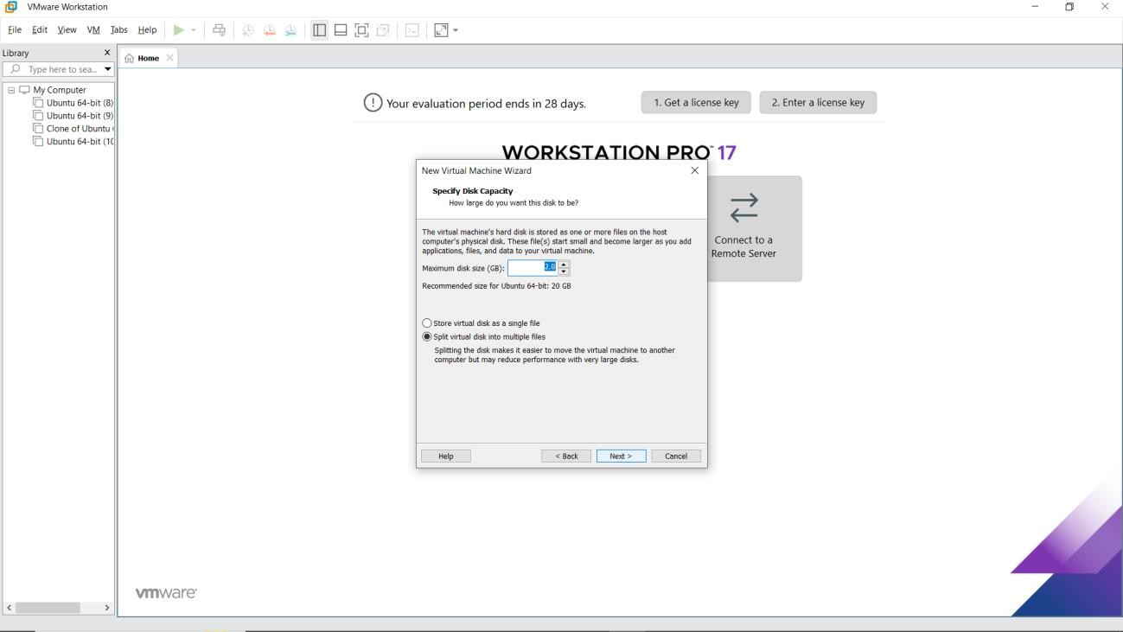

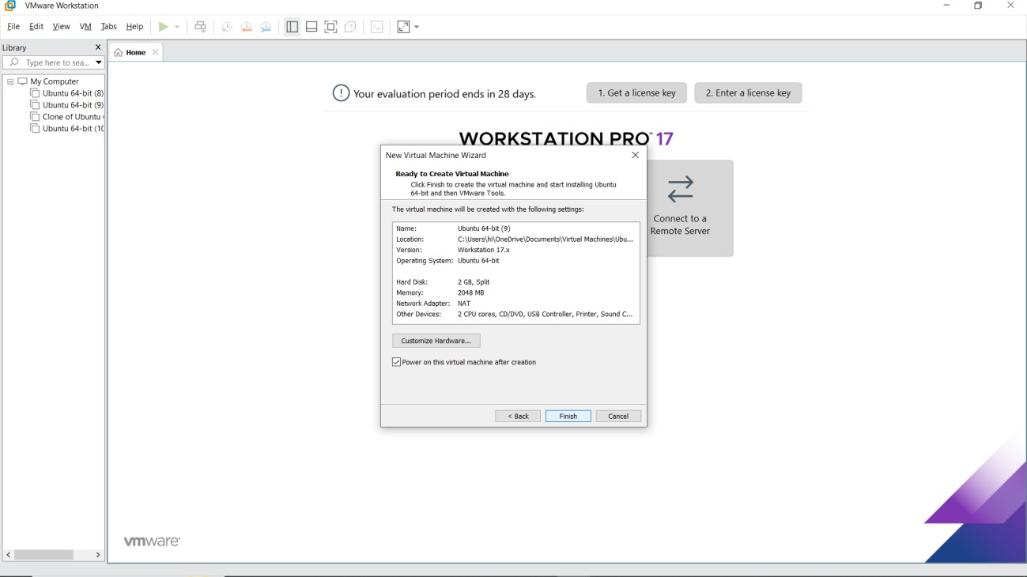
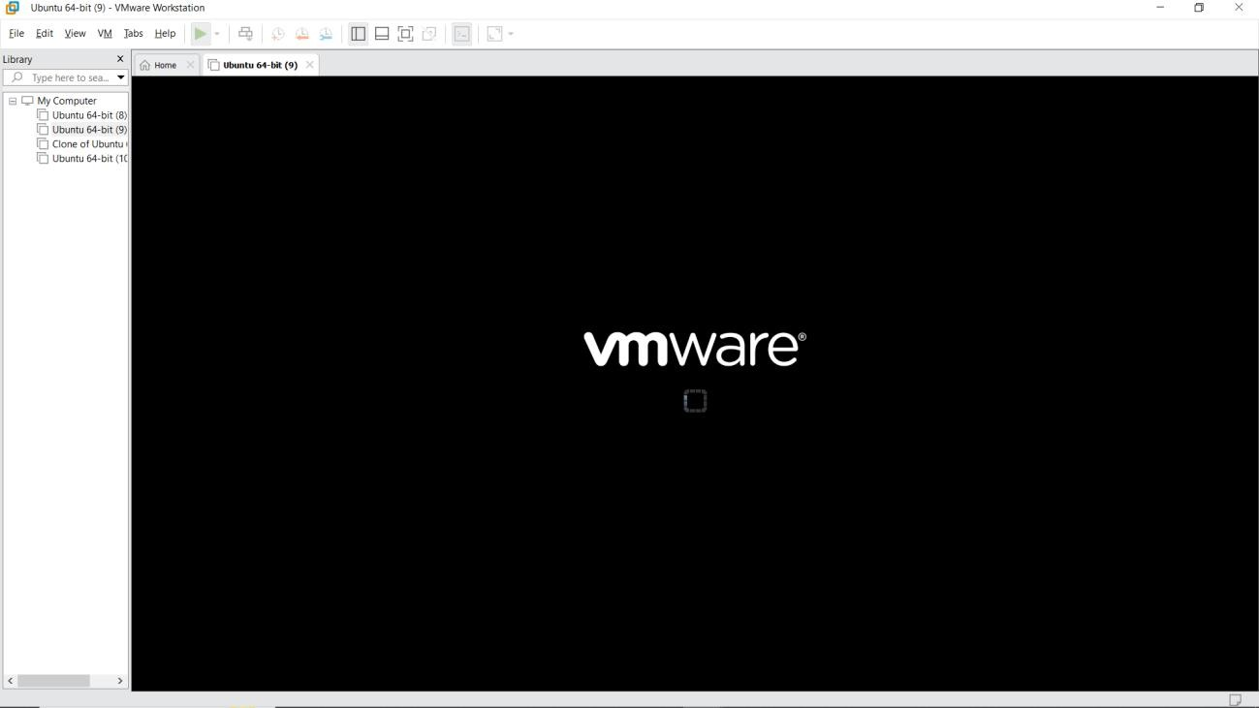
RESULT:
A virtual machine with 1 cpu, 2gb ram and 15gb storage disk using a type 2 virtualization software has been demonstrated.

